**Skill Enhancement Platform**

**Abstract**

Skill enhancement is a cutting-edge platform designed to empower students in their academic journey by enhancing their skills and fostering personal growth. In today's rapidly evolving educational landscape, students face the challenge of acquiring not only academic knowledge but also essential skills required for success in the modern world. Skill enhancement addresses this need by offering a comprehensive array of resources and tools tailored to meet the diverse needs and aspirations of students.

The platform features an intuitive interface that provides easy access to a wide range of learning materials, including interactive courses, educational games, quizzes, and tutorials. Leveraging adaptive learning technology, personalizes the learning experience for each student based on their individual learning preferences, proficiency levels, and academic goals.

Central to effectiveness is its focus on experiential learning and hands-on practice. Through immersive simulations, real-world projects, and gamified activities, students can apply their knowledge in practical contexts, thereby reinforcing their understanding and skill mastery.

Moreover, Skill enhancement fosters collaboration and community engagement among students through discussion forums, group projects, and peer-to-peer learning networks. By encouraging interaction and knowledge sharing, the platform cultivates a supportive learning community where students can learn from each other's experiences and perspectives.

It also provides comprehensive tracking and assessment features, allowing students to monitor their progress, identify areas for improvement, and set learning goals. Teachers and parents can also use these tools to track student performance and provide targeted support and guidance.

In summary, Skill enhancement empowers students to take ownership of their learning journey, develop essential skills, and achieve their full potential. By combining personalized learning, experiential education, and collaborative learning, and aims to revolutionize the way students learn and grow in the digital age.

**CHAPTER 1**

**Introduction**

In today's dynamic and competitive world, the acquisition of skills is essential for students to thrive academically and succeed in their future endeavors. Traditional education often focuses on imparting theoretical knowledge, but there is a growing recognition of the need to complement this with practical skills that are relevant to the demands of the modern workforce.

This recognition has led to the emergence of skill enhancement platforms tailored specifically for students. These platforms offer a holistic approach to education, combining traditional academic subjects with practical skills such as critical thinking, problem-solving, communication, and digital literacy.

The introduction of technology in education has further revolutionized the way students learn and acquire new skills. Skill enhancement platforms leverage advanced technologies such as artificial intelligence, machine learning, and gamification to personalize the learning experience, engage students, and make learning more interactive and enjoyable.

Moreover, skill enhancement platforms provide students with opportunities for experiential learning, allowing them to apply theoretical concepts in real-world scenarios. This hands-on approach not only reinforces their understanding but also helps them develop practical skills that are invaluable in their academic and professional pursuits.

In this paper, we will explore the significance of skill enhancement platforms for students and examine how these platforms are reshaping the education landscape. We will delve into the key features and benefits of skill enhancement platforms, discuss their impact on student learning outcomes, and highlight some notable examples in the field.

By understanding the role of skill enhancement platforms in student education, we can better appreciate their potential to empower students, foster lifelong learning, and prepare them for success in the 21st-century world.

**Methodology**

To develop a skill enhancement platform utilizing MongoDB and ReactJS, a comprehensive methodology must be followed. The process begins with a thorough needs assessment, where the target audience's skill enhancement requirements are analyzed through surveys, interviews, and feedback channels. Subsequently, the platform's architecture is meticulously designed, encompassing the frontend (built with ReactJS), backend (implemented using Node.js and Express.js), and the database layer (utilizing MongoDB). With the development environment set up, backend functionalities are crafted, including the creation of RESTful APIs for user authentication, course management, content delivery, and progress tracking. Concurrently, the frontend is developed, focusing on user interface design and interactive features to facilitate learning, such as course browsing, content access, and community engagement. Integration between the frontend and backend is prioritized, ensuring seamless data flow and user experience. Throughout the development process, rigorous testing and quality assurance measures are implemented, encompassing unit tests, integration tests, and user acceptance testing. Upon completion, the platform is deployed to a cloud hosting provider, configured for optimal performance and scalability. Continuous improvement and iterative development are emphasized post-launch, leveraging user feedback and agile methodologies to refine and enhance the platform's features and functionalities iteratively. This comprehensive approach ensures the successful development and deployment of a robust skill enhancement platform tailored to meet the evolving needs of users.

**Designing the Platform Architecture**:

* Defining the overall architecture of the skill enhancement platform, including the frontend (ReactJS), backend (Node.js), and database (MongoDB).
* Deciding on the data schema and structure in MongoDB to store user profiles, learning materials, courses, assessments, and user progress.

**Setting Up the Development Environment:**

* Installing and configuring MongoDB locally or setting up a cloud-based MongoDB instance for development purposes.
* Creating a new ReactJS project using Create React App or a similar tool for frontend development.

**Backend Development with Node.js and Express:**

* Setting up a Node.js server with Express.js framework for building RESTful APIs.
* Designing and implementing API endpoints for user authentication, course management, content delivery, and progress tracking.
* Integrating MongoDB with Node.js using Mongoose ODM for data manipulation and storage.

**Frontend Development with ReactJS:**

* Designing the user interface (UI) components and layout using ReactJS components and libraries such as Material-UI or Bootstrap.
* Implementing user authentication and authorization features using JSON Web Tokens (JWT) or OAuth.
* Developing interactive features for browsing courses, accessing learning materials, tracking progress, and engaging with community forums.

**Database Integration and Data Management:**

* Establishing connections between the frontend and backend to fetch and display data from MongoDB.
* Implementing data management functionalities such as CRUD operations (Create, Read, Update, Delete) for managing user profiles, courses, and learning materials.
* Handling data validation and error handling to ensure data integrity and security.

**User Engagement and Community Building:**

* Implementing features for user engagement, such as discussion forums, chatrooms, and social sharing.
* Encouraging collaboration and knowledge sharing among users through group projects, peer reviews, and mentorship programs.

**CHAPTER 2**

**SYSTEM SPECIFICATION**

### Software Requirements

|  |  |  |
| --- | --- | --- |
| Operating System | : | Windows 10& above |
| Front end | : | REACT Js |
| Back end  **Hardware Requirements** | : | Mongo DB |
| Processor | : | Intel core i3(min) |
| RAM | : | Minimum 4 GB and Recommended 8 GB |
| Hard Disk | : | 24 GB to accommodate the project files, datasets, and software tools |
| Input Device | : | Standard Keyboard and Mouse |
| Output Device | : | Standard Monitor |

**System Tools**

Visual Studio Code is a fast and efficient source code editor available for Windows, Mac OS X, and Linux on your PC. Together with a strong ecosystem of extensions for additional languages and runtimes (such as C++, C#, Java, Python, PHP, Go, and.NET), it comes with built-in support for JavaScript, TypeScript, and Node.js. Using the Electron Framework, Microsoft created the source code editor Visual Studio Code, or VS Code, for Windows, Linux, and macOS. Embedded Git, snippets, intelligent code completion, debugging support, and syntax highlighting are a few of the features.

**MongoDB**

MongoDB is an open-source document-oriented database that is designed to store a large scale of data and also allows you to work with that data very efficiently. It is categorized under the NoSQL (Not only SQL) database because the storage and retrieval of data in the MongoDB are not in the form of tables.

The MongoDB database is developed and managed by MongoDB.Inc under SSPL(Server Side Public License) and initially released in February 2009. It also provides official driver support for all the popular languages like C, C++, C#, and .Net, Go, Java, Node.js, Perl, PHP, Python, Motor, Ruby, Scala, Swift, Mongoid. So, that you can create an application using any of these languages. Nowadays there are so many companies that used MongoDB like Facebook, Nokia, eBay, Adobe, Google, etc. to store their large amount of data.

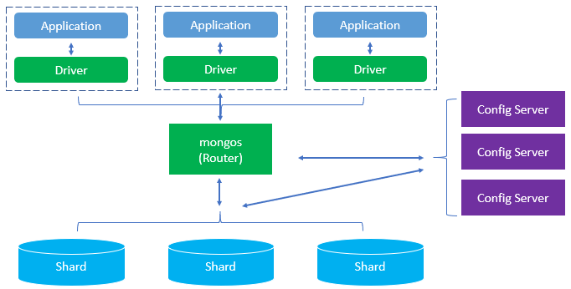

**Reactjs**

React is the most popular javascript library for building user interfaces. It is fast, flexible and it also has a strong community sitting online to help you every time. The coolest thing about React is it’s based on components, you break down your complex code into individual pieces i.e components and that helps developers in organizing their code in a better way. A lot of companies are moving to React and that’s the reason most of the beginners and experienced developers also expanding their knowledge learning this library.

**Working**

React creates a virtual DOM in memory to update the browser’s DOM. The virtual DOM will try to find the most efficient way to update the browser’s DOM.

Unlike browser DOM elements, React elements are simple objects and are cheap to create. React DOM takes care of updating the DOM to match the React elements. The reason for this is that JavaScript is very fast and it’s worth keeping a DOM tree in it to speed up its processing.

Although React was designed to be used in the browser, because of its design allows it to be used on the server with Node.js as well.

**CHAPTER 3**

**SYSTEM ANALYSIS**

**Existing system**

Student information including personal details, academic records manually in paper-based files or spreadsheets, leading to inefficiencies in data retrieval and updates. Communication between students, teachers, and administrators primarily occurs face-to-face or via email. There's no centralized platform for communication, resulting in delays and limited accessibility to information. Video Conferencing facility is not available in existing system. So student cannot attend online classes. When students are absent each and every subject classes are missed.

Access to academic resources and student records is restricted to physical locations such as administrative offices or classrooms. Students may encounter difficulties in accessing information remotely or outside of regular operating hours.

The system lacks integration with modern technologies, hindering automation of tasks such as generating reports facilitating online learning. This reliance on manual processes contributes to inefficiencies and potential errors in data management.

**Disadvantages of Existing system**

The disadvantages of existing skill enhancement platforms can vary depending on the specific platform and its features, but here are some common drawbacks:

**Lack of Personalization:**

* Users have varying learning styles, paces, and preferences. Skill enhancement platforms that lack personalization may not adapt content delivery or learning pathways to suit individual needs.
* This can result in some users feeling disengaged or frustrated, as the learning experience may not cater to their specific requirements.

**Limited Feedback and Interaction:**

* Effective learning often requires feedback and interaction. Platforms that fail to provide avenues for users to receive feedback on their progress or to interact with instructors or peers may hinder skill development.
* Without constructive feedback, users may struggle to identify areas for improvement and may feel isolated in their learning journey.

**Outdated Content:**

* In rapidly evolving industries, such as technology or healthcare, outdated content can quickly become obsolete.
* Skill enhancement platforms may struggle to keep pace with the latest developments, resulting in users learning outdated techniques or information. This can be detrimental to users who rely on these platforms to stay relevant in their fields.

**High Cost:**

* The cost of accessing skill enhancement platforms can be prohibitive for many individuals, particularly those with limited financial resources.
* High subscription fees or course prices may prevent users from accessing valuable learning opportunities, restricting their ability to acquire new skills and advance in their careers.

**Lack of Practical Application:**

* Theoretical knowledge is important, but without opportunities for practical application, users may struggle to translate what they've learned into real-world scenarios.
* Skill enhancement platforms that do not offer hands-on projects or practical exercises may fail to adequately prepare users for applying their skills in professional settings.

**Limited Scope of Offerings:**

* Some platforms may specialize in specific areas or industries, limiting the range of skills that users can develop.
* This can be a disadvantage for individuals seeking comprehensive skill enhancement across various domains, as they may need to subscribe to multiple platforms or seek supplementary resources to meet their learning objectives.

**Ineffective Assessment Methods:**

* Assessments are essential for gauging skill proficiency and growth. However, platforms that rely solely on standardized tests or quizzes may not provide an accurate reflection of a user's abilities.
* Effective assessment methods should be comprehensive, varied, and aligned with learning objectives to ensure users are accurately evaluated.

**Poor User Experience:**

* A cluttered interface, unintuitive navigation, or frequent technical glitches can detract from the overall user experience of a skill enhancement platform.
* Poor user experience can hinder user engagement and retention, as users may become frustrated or disenchanted with the platform's usability issues.

**Lack of Recognition or Certification:**

* Without recognized certifications or credentials, users may struggle to validate their skills to employers or advance in their careers.
* Skill enhancement platforms that do not offer certification programs or industry-recognized credentials may limit users' ability to leverage their newly acquired skills in professional settings.

**Privacy and Security Concerns:**

* Users may be wary of sharing personal information or sensitive data on skill enhancement platforms due to concerns about privacy and security.
* Platforms that do not prioritize data protection or are vulnerable to data breaches may deter users from fully engaging with the platform or sharing personal information necessary for effective learning.

Addressing these detailed concerns requires a concerted effort from platform developers to prioritize user needs, incorporate feedback mechanisms, update content regularly, ensure affordability and accessibility, offer practical learning experiences, diversify offerings, implement effective assessment methods, optimize user experience, provide recognition and certification options, and prioritize privacy and security measures.

**Proposed system**

Authentication and Authorization: Implement user authentication and authorization using JSON Web Tokens (JWT) to ensure secure access to student data and functionalities based on user roles (e.g., student, teacher)

File Uploading and Downloading: Enable file uploading and downloading capabilities for sharing resources such as lecture notes and reference materials. Utilize cloud storage services for efficient file management and accessibility.

Virtual Classroom with Video Conferencing: Integrate video conferencing APIs to enable virtual classroom functionalities, including live lectures, interactive discussions, screen sharing, and recording capabilities.

The potential advantages of a proposed system for a skill enhancement platform:

**Personalized Learning Paths:**

The proposed system can offer personalized learning paths tailored to individual users' goals, preferences, and learning styles. By leveraging user data and analytics, the platform can recommend relevant courses, resources, and activities to optimize learning outcomes.

**Interactive Learning Environment:**

The proposed system can facilitate interaction and collaboration among users through features such as discussion forums, group projects, and live sessions with instructors. This fosters a sense of community and engagement, enhancing the learning experience.

**Real-time Feedback and Assessment:**

The platform can provide real-time feedback and assessment mechanisms, allowing users to track their progress, identify areas for improvement, and receive timely guidance from instructors or mentors. This promotes continuous learning and skill development.

**Up-to-date Content and Resources:**

The proposed system can ensure that content and resources are regularly updated to reflect the latest developments and trends in various industries and fields. This ensures that users have access to relevant and cutting-edge information, keeping their skills current and marketable.

**Affordability and Accessibility:**

The platform can offer flexible pricing options, including subscription models, pay-per-course options, or free access to certain basic features. Additionally, the platform can be designed to be accessible across devices and internet connections, catering to users with diverse socioeconomic backgrounds and geographical locations.

**Hands-on Learning Opportunities:**

The proposed system can incorporate hands-on learning opportunities, such as practical exercises, case studies, simulations, and real-world projects. This allows users to apply theoretical knowledge in practical settings, reinforcing their understanding and skill mastery.

**Comprehensive Skill Development:**

The platform can offer a wide range of courses, workshops, and resources covering various skills and domains, enabling users to pursue comprehensive skill development. Whether it's technical skills, soft skills, or industry-specific knowledge, the platform provides a holistic learning experience.

**Recognition and Certification:**

The proposed system can offer recognized certifications and credentials upon completion of courses or mastery of skills. These certifications serve as valuable credentials that users can showcase to employers, boosting their credibility and employability in the job market.

**User-friendly Interface and Experience:**

The platform can prioritize user experience by offering a intuitive interface, seamless navigation, and responsive design. This ensures that users can easily navigate the platform, access content, and engage with learning activities without encountering usability issues or technical barriers.

**Data Privacy and Security:**

The proposed system can implement robust data privacy and security measures to safeguard users' personal information and ensure compliance with relevant regulations. This builds trust and confidence among users, encouraging them to fully engage with the platform without concerns about privacy or security risks.

By leveraging these advantages, the proposed system can create a dynamic and effective learning environment that empowers users to enhance their skills, achieve their goals, and succeed in their careers.

**CHAPTER 4**

**SYSTEM DESIGN**

**Input design**

**Screenshot**

**Output design**

**Screenshot**

**Database**

**Screenshot**

**CHAPTER 5**

**Conclusion**

In conclusion, a skill enhancement platform holds immense potential to revolutionize the way individuals learn, develop, and showcase their skills in today's rapidly evolving world. By leveraging innovative technologies and pedagogical approaches, such platforms can address the shortcomings of traditional learning methods and provide a more personalized, interactive, and effective learning experience.

Through personalized learning paths, interactive features, real-time feedback mechanisms, and up-to-date content, skill enhancement platforms empower users to pursue continuous learning and skill development tailored to their unique goals and preferences. By offering hands-on learning opportunities, comprehensive course offerings, and recognized certifications, these platforms equip users with the knowledge, skills, and credentials needed to succeed in their chosen fields.

Moreover, by prioritizing affordability, accessibility, user experience, and data privacy, skill enhancement platforms ensure that learning is inclusive, engaging, and secure for users from diverse backgrounds and locations.

In essence, skill enhancement platforms represent a transformative force in education and professional development, democratizing access to learning opportunities, bridging skill gaps, and unlocking individuals' potential to thrive in an ever-changing global economy. As these platforms continue to evolve and innovate, they are poised to play a pivotal role in shaping the future of learning and work, empowering individuals to adapt, grow, and succeed in an increasingly competitive and dynamic landscape.

**Future Enhancement**

the future of skill enhancement platforms holds promise for significant advancements that can revolutionize how individuals learn and develop their capabilities. Integration of cutting-edge technologies such as artificial intelligence (AI), augmented reality (AR), and blockchain presents exciting opportunities for enhancing the effectiveness and accessibility of these platforms. AI algorithms can enable personalized learning experiences tailored to each user's needs and preferences, while AR can create immersive training simulations for practical skill application. Additionally, blockchain technology can offer secure and verifiable credentialing, ensuring the authenticity of users' achievements. Moreover, the incorporation of gamification elements, social learning features, and multimodal resources enhances engagement and interaction, fostering a vibrant learning community. Continual content updates and adaptive assessments further ensure that learning experiences remain relevant and effective. By prioritizing accessibility and inclusivity features, skill enhancement platforms can reach a broader audience and empower individuals from diverse backgrounds to thrive in their personal and professional pursuits. These advancements represent a significant step forward in democratizing access to education and empowering individuals to adapt and succeed in an ever-evolving global landscape.

Moreover, the integration of gamification elements, social learning features, and multimodal resources will enrich engagement and collaboration within learning communities. Gamification mechanics such as badges, leaderboards, and rewards will motivate users to progress and achieve mastery, while social learning features such as discussion forums and peer-to-peer mentorship will facilitate knowledge sharing and peer support. Additionally, the provision of multimodal resources, including videos, podcasts, and interactive tutorials, will accommodate diverse learning preferences and ensure accessibility for all users.

Continual updates to content and assessments, driven by real-time data analytics and user feedback, will ensure that learning materials remain current, relevant, and aligned with industry trends and best practices. Adaptive assessment mechanisms will provide personalized feedback and guidance, identifying areas for improvement and tailoring learning experiences to individual proficiency levels. Furthermore, a steadfast commitment to accessibility and inclusivity will ensure that skill enhancement platforms remain accessible to users of all backgrounds and abilities, fostering a culture of lifelong learning and equitable opportunity.

In essence, these future enhancements represent a bold step forward in the evolution of skill enhancement platforms, promising to empower individuals worldwide to unlock their full potential and thrive in an ever-changing global landscape of learning and work.

**ER diagram**

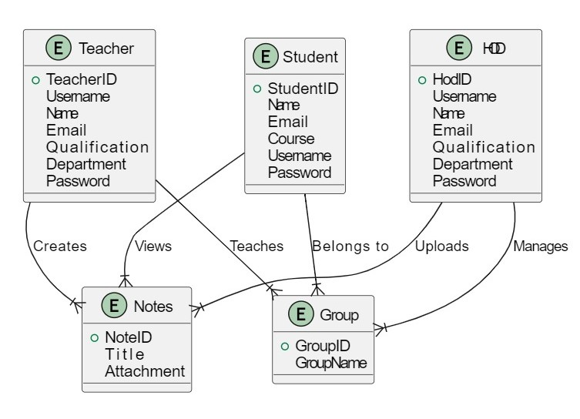

**Architecture diagram**

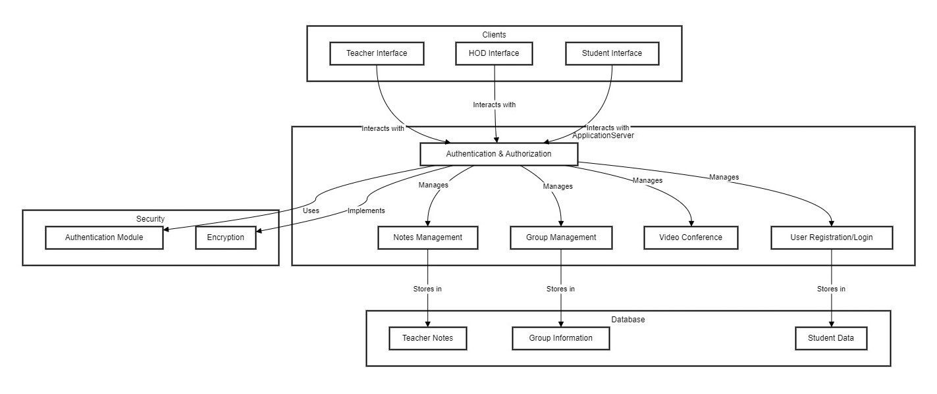

**Block diagram**

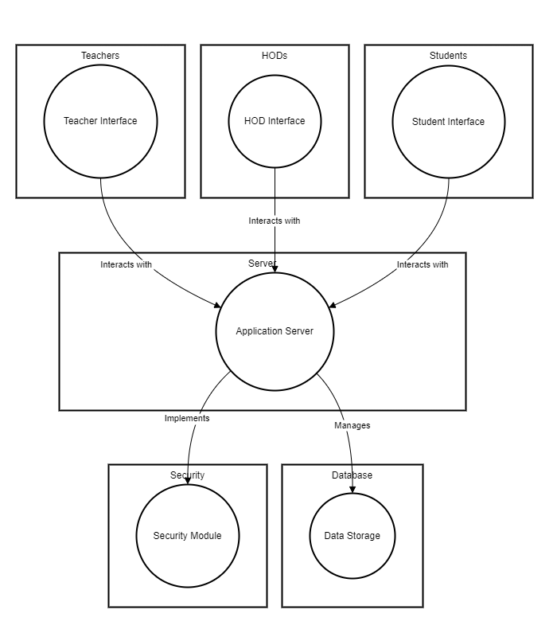

**Flow diagram**

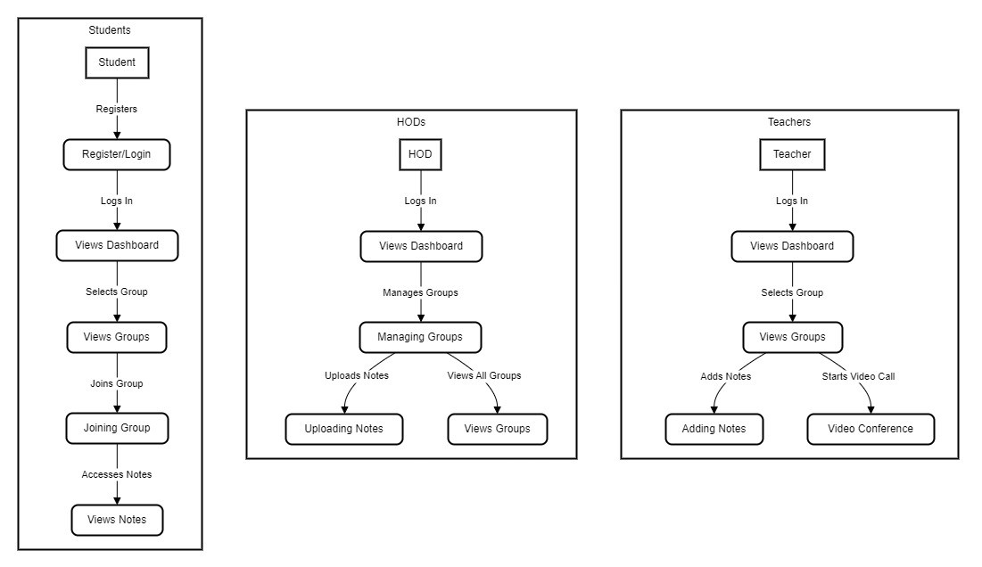

**Data flow diagram**

**\**

